**Tuberculosis Basics**

* What is it: the spectrum of tuberculosis (TB) from infection to active disease (see figure from [Nature Primer on TB](http://www.letstalktb.org/wp-content/uploads/2015/11/nature-tb-review-2016.pdf)). TB is caused by *Mycobacterium tuberculosis*, a rod-shaped bacillus. 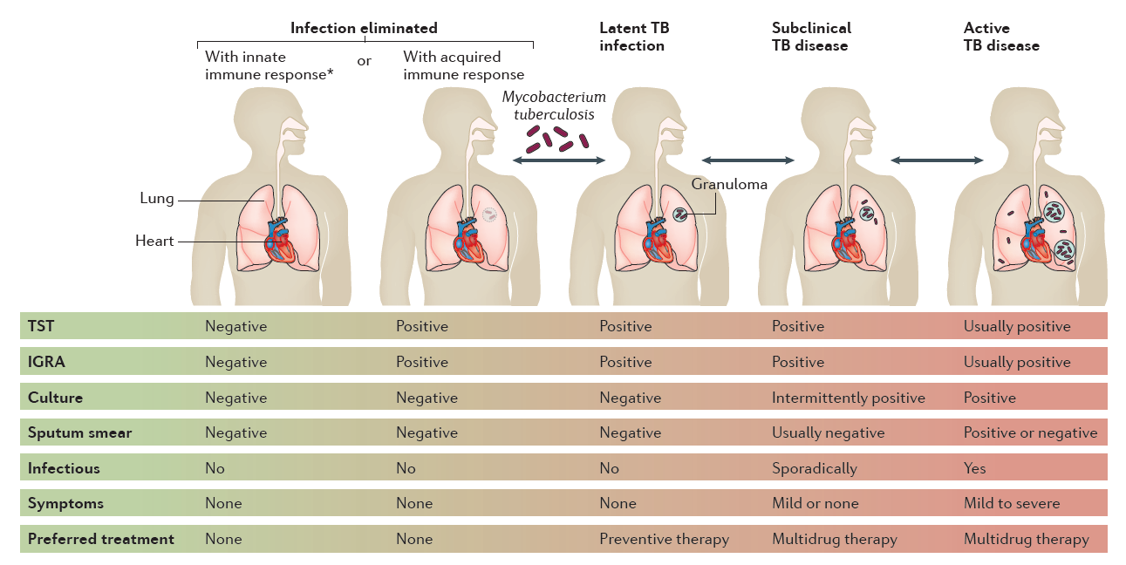
* Symptoms: Classic 3 are: Cough, night sweats, weight loss.
* How it is diagnosed- clinical vs. microbiologically-confirmed. Combination of:
  + Symptoms
  + Chest radiograph
  + TST (tuberculin skin test) or IGRA history
  + Sputum smear (look for bugs under microscope- quick turnaround, can be +,++, +++, ++++)
  + Culture (try to grow bugs in the lab- can take weeks)
* Factors affecting transmission
  + Patient factors
    - Cavitary TB disease (cavities in lungs filled with TB) are more infectious
    - Laryngeal > Pulmonary > Other respiratory > Other sites
    - Miliary, abdominal and other sites are much less infectious
    - Children under 10 rarely transmit to others (not good cough mechanics)
    - Risk factors such as sharing smoking devices
  + Environmental factors
    - Ventilation and air circulation
    - Overcrowding
* Contact tracing: Typically look back 3 months from symptom onset (this can be tricky when dealing with a population that always has a cough)